**Practical 04 Digital Presentation**

**Representing colour in RGB**

1. 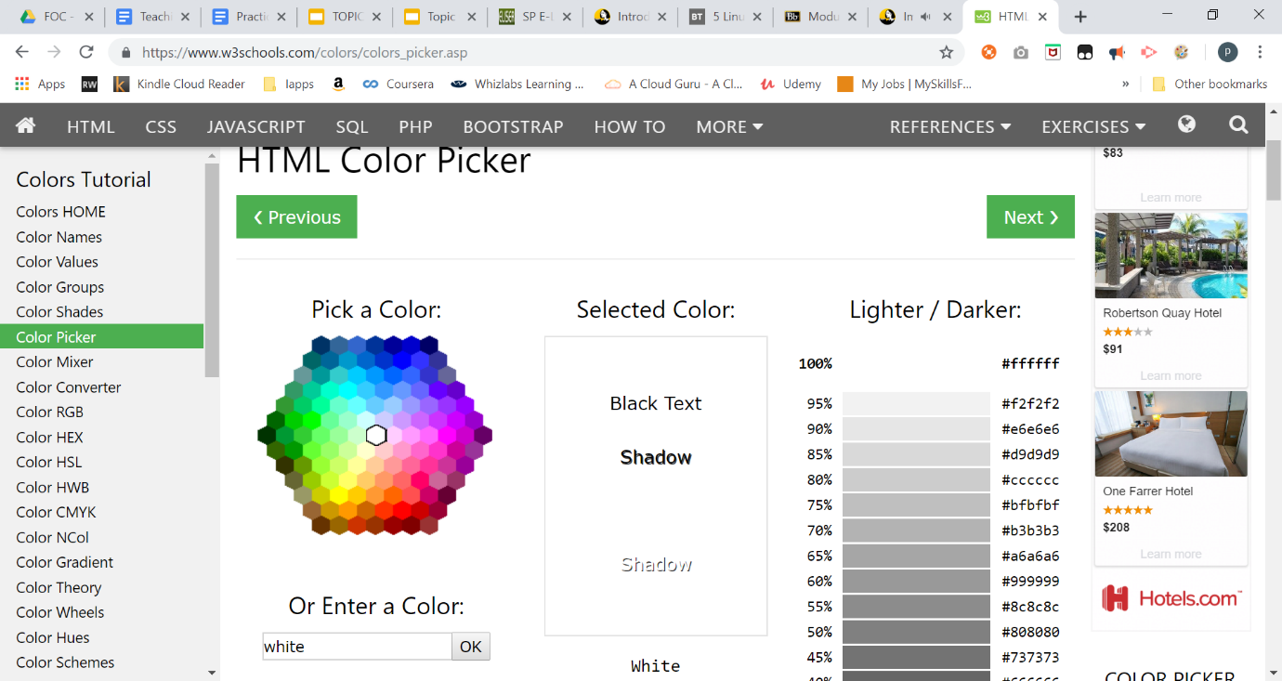Go to web site <https://www.w3schools.com/colors/colors_picker.asp>

|  |  |  |
| --- | --- | --- |
| **Colour** | **RGB in decimal** | **RGB In Hex** |
| Black | **(0,0,0)** | **#000000** |
| White | **(255,255,255)** | #ffffff |
| Your favourite colour: Green | (102, 255, 51) | **#66ff33** |

Access the File Header

1. Using notepad, create a text file named “file1.txt”

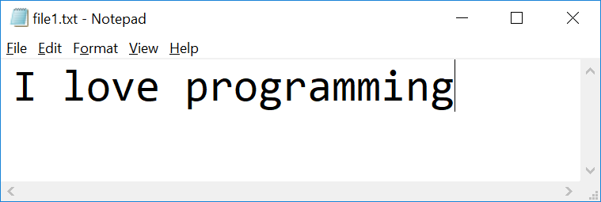

1. Check the file properties

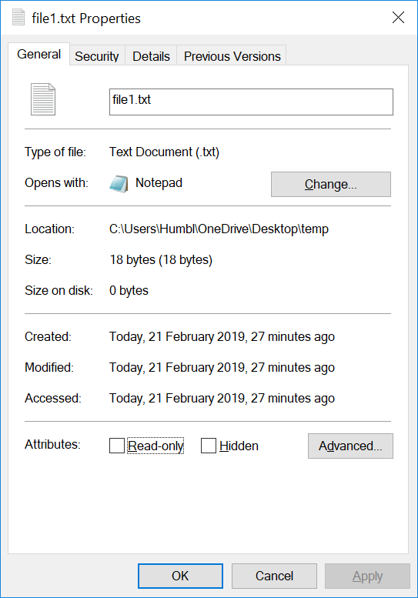

What is the size of the file in bytes?

|  |
| --- |
| 18 bytes |

1. Visit HexEd at <https://hexed.it/>

or download HxD Hex Editor

<https://download.cnet.com/HxD-Hex-Editor/3000-2352-10891068.html?part=dl-HxDHexEdi&subj=uo&tag=button>

1. Open file1.txt using HxD
2. Observe the Hex code  
   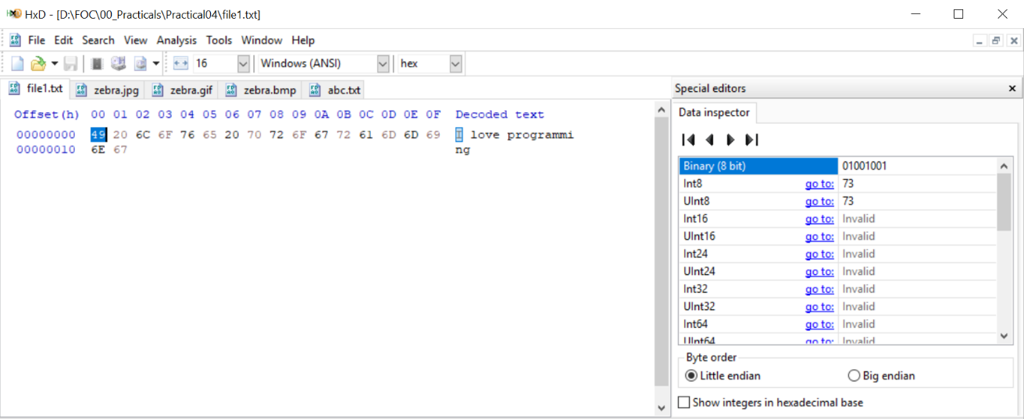

|  |  |  |
| --- | --- | --- |
| **Character** | **Hex** | **Binary(8 bit)** |
| I | 49 | 01001001 |

|  |  |  |  |  |  |  |  |
| --- | --- | --- | --- | --- | --- | --- | --- |
|  |  | 4 |  |  | 9 |  |  |
| 8 | 4 | 2 | 1 | 8 | 4 | 2 | 1 |
| 0 | 1 | 0 | 0 | 1 | 0 | 0 | 1 |

1. Using HxD to observe how character “o” and space character are represented

|  |  |  |
| --- | --- | --- |
| **Character** | **Hex** | **Binary(8 bit)** |
| o | 6F | 0110 1111 |
| space | 20 | 0010 0000 |
|  |  |  |

1. 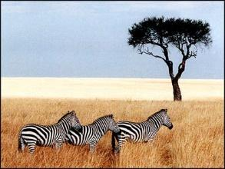Download the following image and save it as zebra.**jpg**, zebra.**gif** and zebra.**bmp**
2. Open **zebra.gif** in HxD

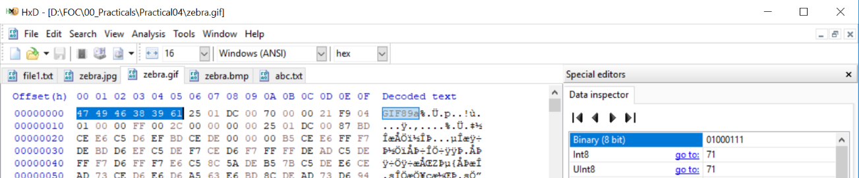Observe the Hex code

What are the **first 6 bytes** decoded?

|  |  |  |  |  |  |  |
| --- | --- | --- | --- | --- | --- | --- |
| **offset** | **00** | **01** | **02** | **03** | **04** | **05** |
| Byte | 47 | 49 | 46 | 38 | 39 | 61 |
| Character | G | I | F | 8 | 9 | a |

1. Visit web site <https://en.wikipedia.org/wiki/List_of_file_signatures> to find out the meaning of above hex code

|  |
| --- |
| Image Image file encoded in the Graphics Interchange Format (GIF) |

1. Open **zebra.jpg** in HxD  
     
   Observe the Hex code

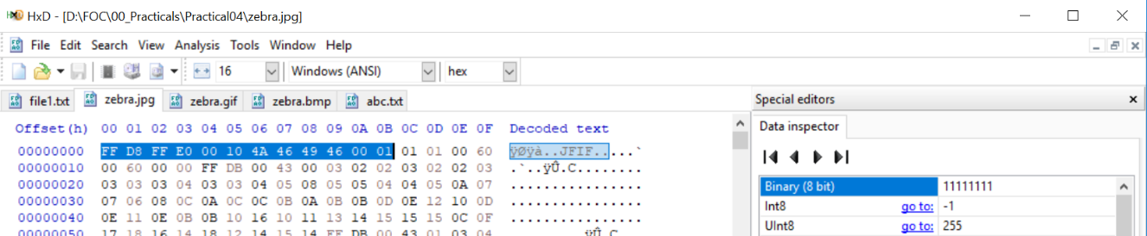

What are the **first 12 bytes**?

|  |  |  |  |  |  |  |  |  |  |  |  |  |
| --- | --- | --- | --- | --- | --- | --- | --- | --- | --- | --- | --- | --- |
| **offset** | **00** | **01** | **02** | **03** | **04** | **05** | **06** | **07** | **08** | **09** | **0A** | **0B** |
| Byte | FF | D8 | FF | E0 | 00 | 10 | 4A | 46 | 49 | 46 | 00 | 01 |
| Character |  |  |  |  |  |  | J | F | I | F |  |  |

1. Visit web site <https://en.wikipedia.org/wiki/List_of_file_signatures> to find out the meaning of above hex code

|  |
| --- |
| JPEG Raw or in the JFIF or Exif file forma |

1. Open **zebra.bmp** in hex editor

Observe the Hex code   
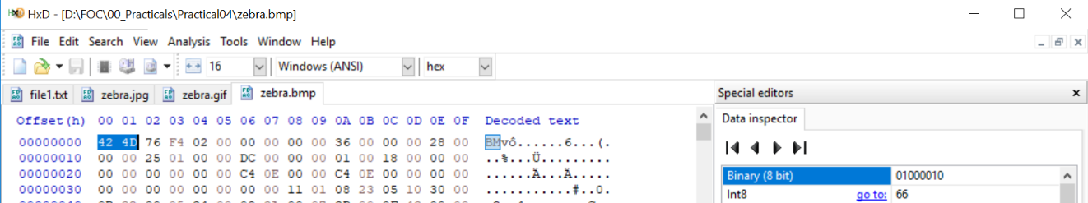

What are the **first 2 bytes**?

|  |  |  |
| --- | --- | --- |
| **offset** | **00** | **01** |
| Byte | 42 | 4D |
| Character | B | M |

1. Visit web site <https://en.wikipedia.org/wiki/List_of_file_signatures> to find out the meaning of above hex code

|  |
| --- |
| BMP file, a bitmap format used mostly in the Windows world |

1. (optional)  
   Download the file at <https://drive.google.com/open?id=1vf0SBkI1LdWQvYmK9yM5AyJ0fHKE6DHR>

How can you view it as an image?

|  |  |  |
| --- | --- | --- |
| **offset** | **00** | **01** |
| Byte | 42 | 4D |
| Character | B | M |
|  |  |  |

|  |
| --- |
| BM = BMP file format.  So since the 1st and 2nd bye contains the hex code, BM, I renamed the file extension from .txt into the extension, .bmp |

**Hint:**

* Open the file using HxD
* Visit web site <https://en.wikipedia.org/wiki/List_of_file_signatures> to find out the meaning of above hex code
* Rename the extension of the file

2. What have you learnt?   
Today, I have learnt a lot about how bytes can store characters that come together under a certain file extension to display an image. For example, the extensions of the files can be found by converting the bytes to hex codes. This can also be used to convert a wrong extension type of a file such as the one in question 14 to the correct file extension, thus enabling it to properly display a picture.

3. Difficulties encountered and how you solved the problems?  
 At first, I was unsure as to how bytes can be converted to hex codes and vise versa. However, after asking the teacher about it, he teaches us how to manually convert binary to characters in the hexdecimal by adding 1 to every binary after the number 9. So after 9, it will be A with the binary 1010.

*End of Practical*